**DATA ANALITICS PROJECT**

**Install and Launch Power BI:** If you haven't already, you can download and install Power BI Desktop from the official Microsoft website. Once installed, launch the application.

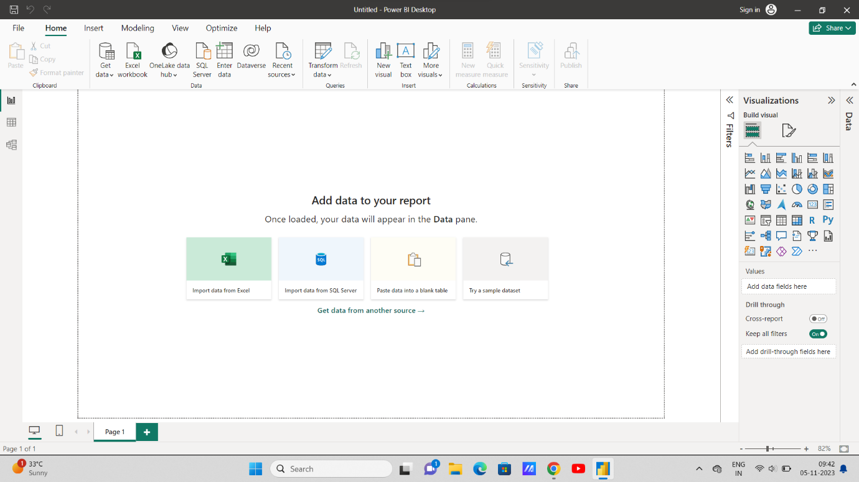

**Get Data:**

• When you open Power BI, you'll see the "Home" tab. Click on the "Get Data" button to start importing your data.

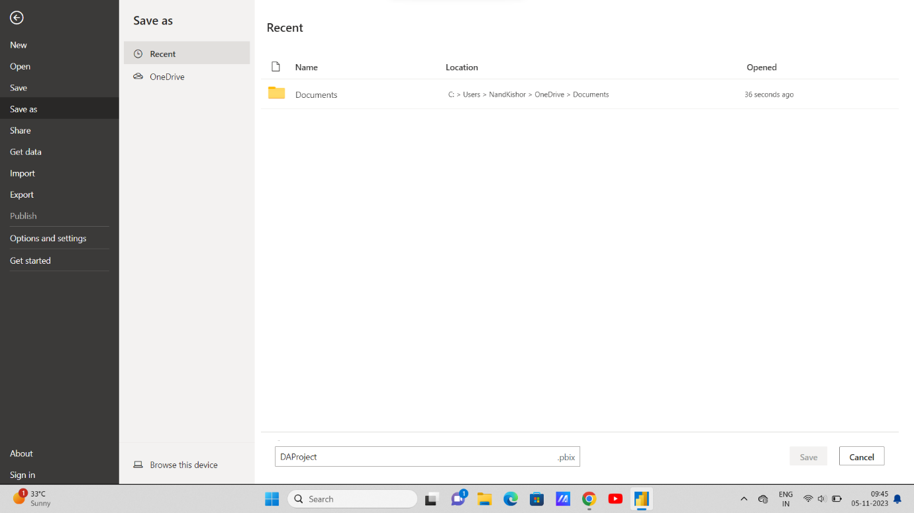

**Choose a Data Source:**

• Power BI supports various data sources, such as Excel, databases, web services, and more. Select the appropriate source for your data. For example, if you have an Excel file, choose "CSV" and browse for your file.

Data Load and Transformation:

• Once you connect to your data, Power BI will load it into the Query Editor. Here, you can transform and clean your data. You can remove unnecessary columns, rename columns, filter rows, and perform other data cleaning operations.

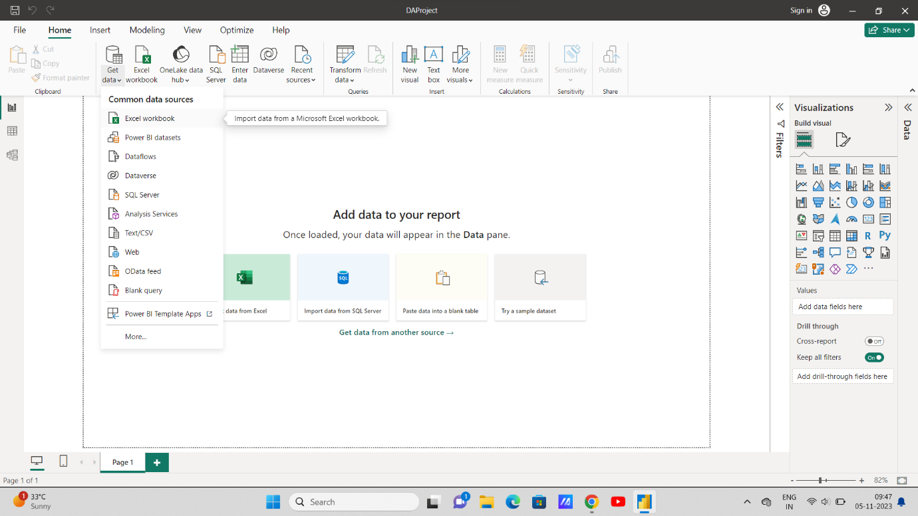

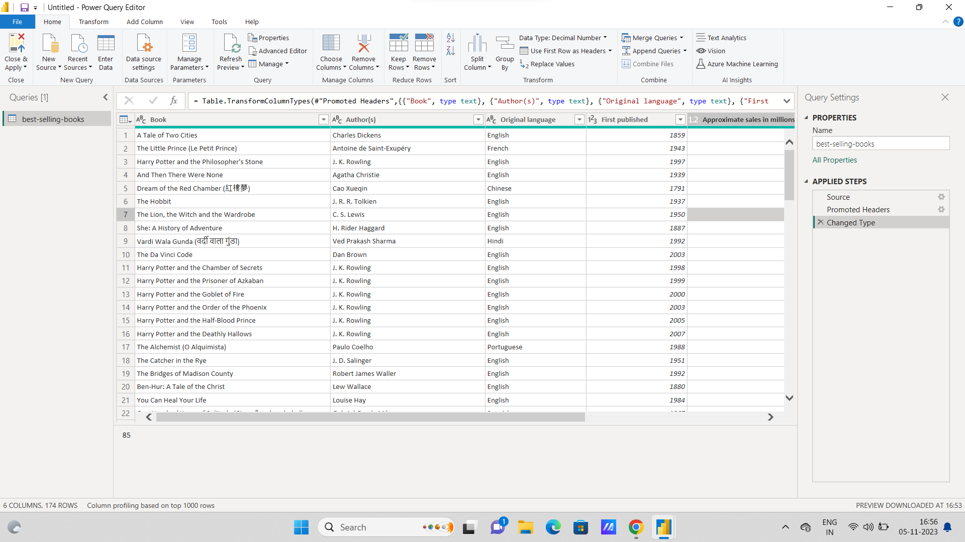

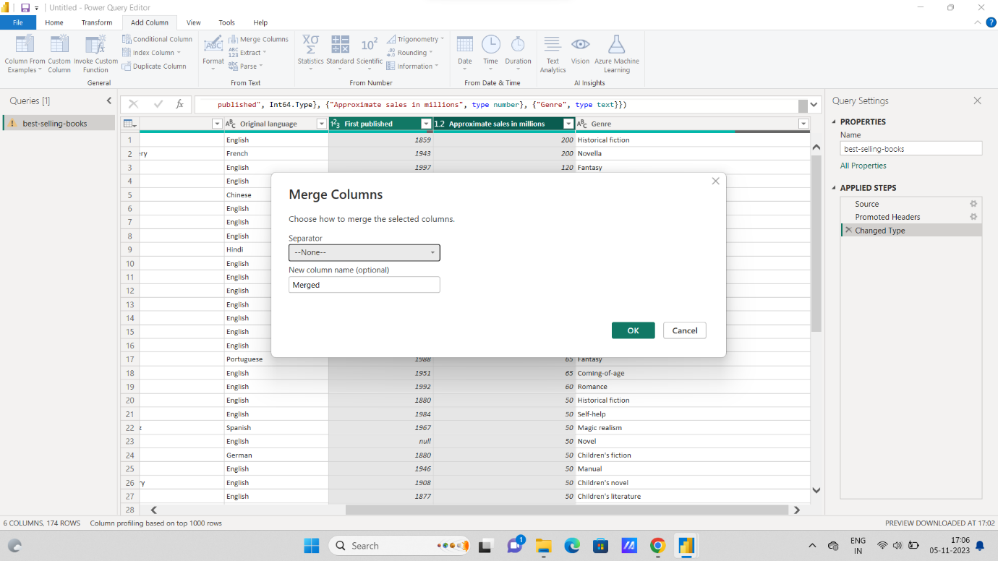

**Combine Columns in the Power Query Editor:**

Load your data into Power BI, and then go to the "Edit Queries" option. You can do this by selecting "Edit Queries" from the Home tab or right-clicking on your data source in the Fields pane and selecting "Edit Queries."

In the Power Query Editor, select the table that contains the columns you want to merge.

Select the columns you want to merge. You can do this by holding down the Ctrl key and clicking on the column headers.

Once the columns are selected, go to the "Transform" tab and click on the "Merge Columns" option.

In the "Merge Columns" dialog box, you can choose the delimiter that will be used to separate the values from the merged columns. You can also specify a new column name for the merged column.

Click "OK" to apply the merge operation.

You will now have a new column that contains the merged values.

Finally, click the "Close & Apply" button in the Power Query Editor to save the changes and load the data back into Power BI.

**Option 2:** Combine Columns in Power BI Desktop:

Load your data into Power BI.

In the "Data" view, select the table that contains the columns you want to merge.

Create a new calculated column by going to the "Modeling" tab and selecting "New Column."

In the formula bar, you can use the "&" operator to concatenate the values from the columns you want to merge. For example, if you want to merge "Column1" and "Column2," your formula could look like this:

MergedColumn = [Column1] & " " & [Column2]

Press Enter to create the calculated column, and it will contain the merged values.

You can rename the calculated column by double-clicking on the column name in the Fields pane.

Your merged column is now ready for use in visuals and analysis.

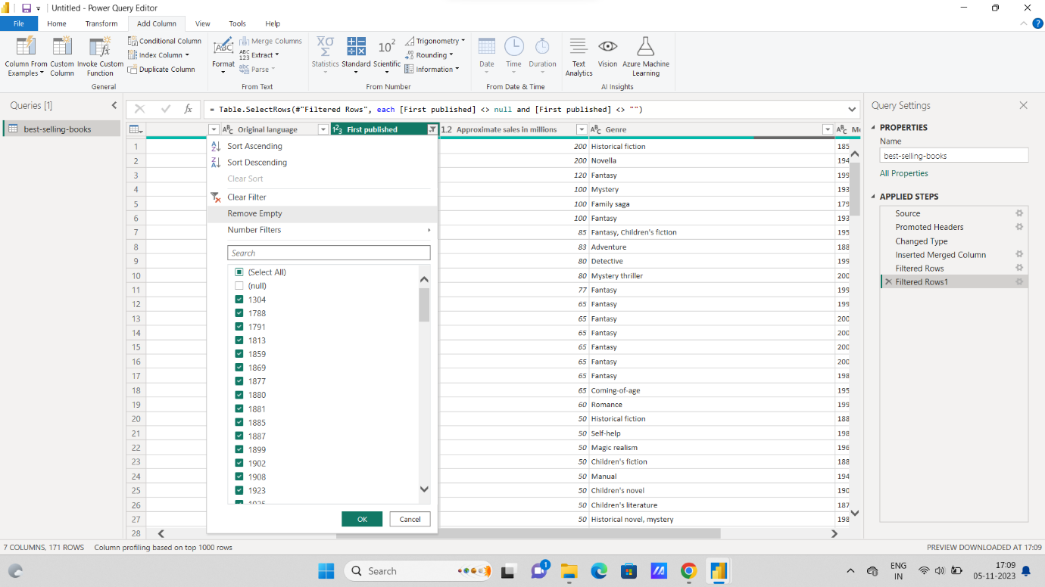

Go to the "Edit Queries" option. You can do this by selecting "Edit Queries" from the Home tab or right-clicking on your data source in the Fields pane and selecting "Edit Queries."

In the Power Query Editor, select the table that contains the column with null values.

Select the column from which you want to remove null values.

In the "Transform" tab, you can use the "Replace Values" option to replace null values with a value of your choice or remove rows with null values.

a. To replace null values with a specific value, click on "Replace Values," specify "null" as the value to replace, and provide the replacement value.

b. To remove rows with null values, you can use the "Remove Rows" option. Select "Remove Rows" and choose "Remove Nulls" to eliminate rows with null values in the selected column.

After applying the desired transformation, click the "Close & Apply" button in the Power Query Editor to save the changes and load the data back into Power BI.

Remove Null Values using DAX (Data Modeling view):

In the Data Modeling view, select the table that contains the column with null values.

Create a new calculated column by going to the "Modeling" tab and selecting "New Column."

Use a DAX function like FILTER or IF to remove rows with null values. For example, if you have a column called "MyColumn," you can create a calculated column like this:

NewColumn = FILTER('YourTableName', 'YourTableName'[MyColumn] <> BLANK())

This DAX formula filters out the rows where "MyColumn" is null or empty.

Press Enter to create the calculated column, and it will contain the values from the original column with null values removed.

You can rename the calculated column by double-clicking on the column name in the Fields pane.

Your new calculated column will not contain any null values.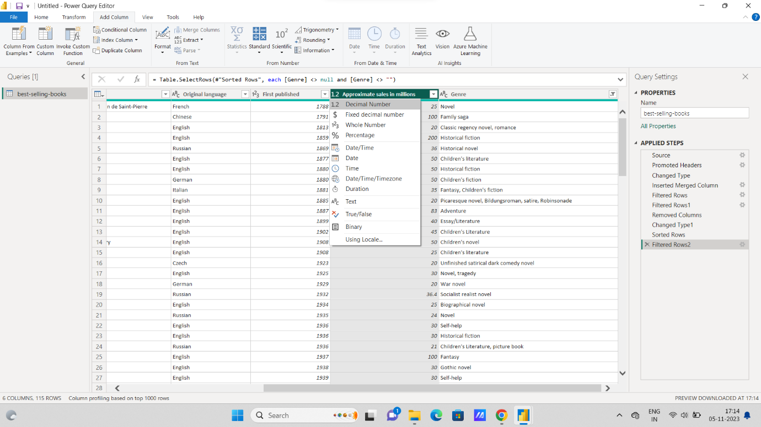

Right-click on the selected column, and in the context menu, choose "Change Type."

A submenu will appear, showing several options for changing the data type, including "Whole Number," "Decimal Number," "Text," "Date," "Date/Time," and more. Select the appropriate data type for your column.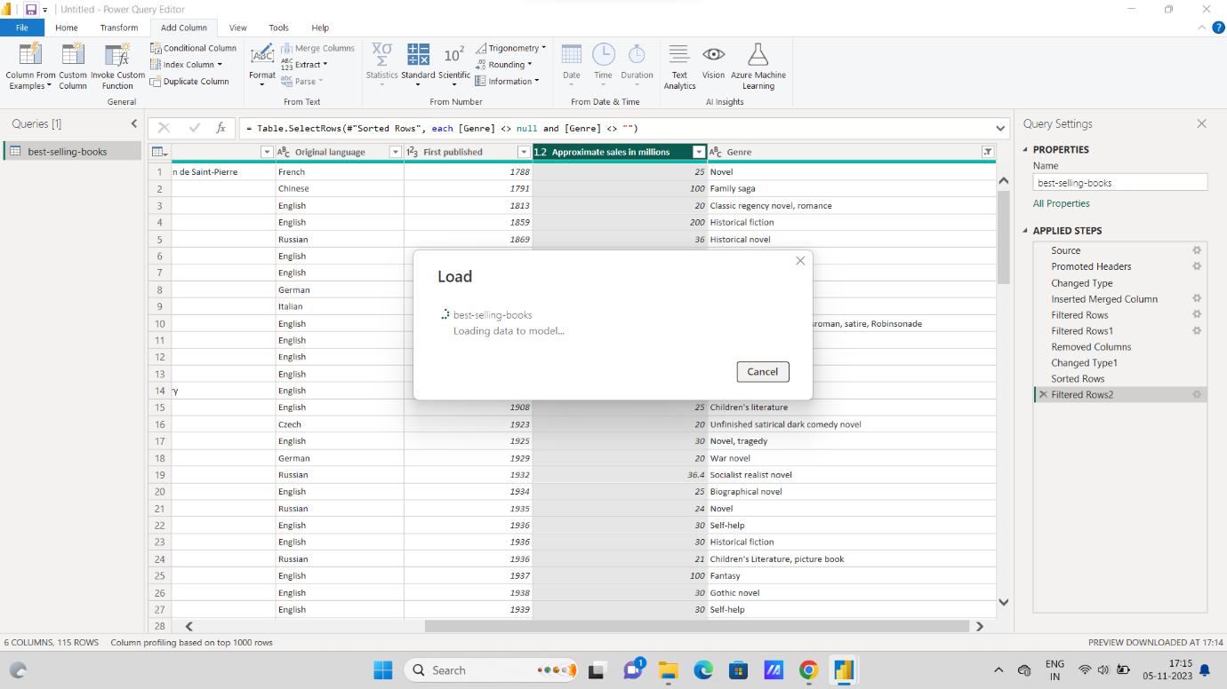

Loading data into Power BI is a fundamental step in creating reports and dashboards. Power BI allows you to connect to various data sources, transform and shape the data, and load it into your data model. Here are the steps to load data into Power BI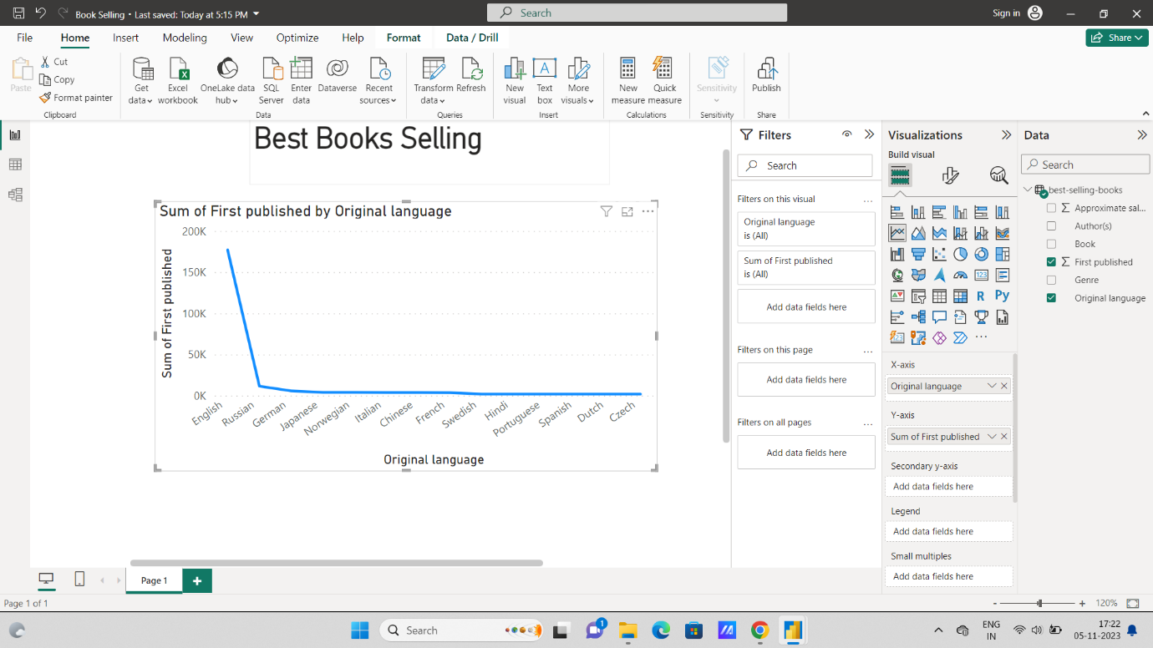

**Load Data:**

First, load your data into Power BI using the steps mentioned in a previous response.

**Open Report View:**

In Power BI Desktop, click on the "Report" icon in the left-hand panel to enter the report view.

**Select Line Chart Visualization:**

In the "Visualizations" pane on the right side of the screen, you'll see a gallery of visualization types. To create a line chart, click on the "Line Chart" icon.

**Fields and Axis:**

In the "Visualizations" pane, you will see the "Fields" section.

Drag and drop the field that you want to use as the X-axis onto the "Axis" section in the "Fields" pane. This field will be used for your line chart's horizontal axis (usually a date or time-based field).

Drag and drop the field that you want to visualize as the Y-axis onto the "Values" section in the "Fields" pane. This field represents the data you want to plot on the vertical axis.

**Customize the Line Chart:**

You can further customize your line chart by using the "Visualizations" pane.

You can add more fields to the "Legend" section to create multiple lines in the chart, each representing different categories or data series.

You can format the axis scales, title, and other properties by using the formatting options in the "Format" section of the "Visualizations" pane.

**Interact with the Line Chart:**

In the report view, you can interact with the line chart. You can hover over data points to see tooltips with details, zoom in on a specific time range, or cross-highlight related visuals by selecting data points.

**Save Your Report:**

Be sure to save your report periodically by going to "File" and selecting "Save" to save your changes.

**Decision:-** Analysis of this line chart to selling book language in English. 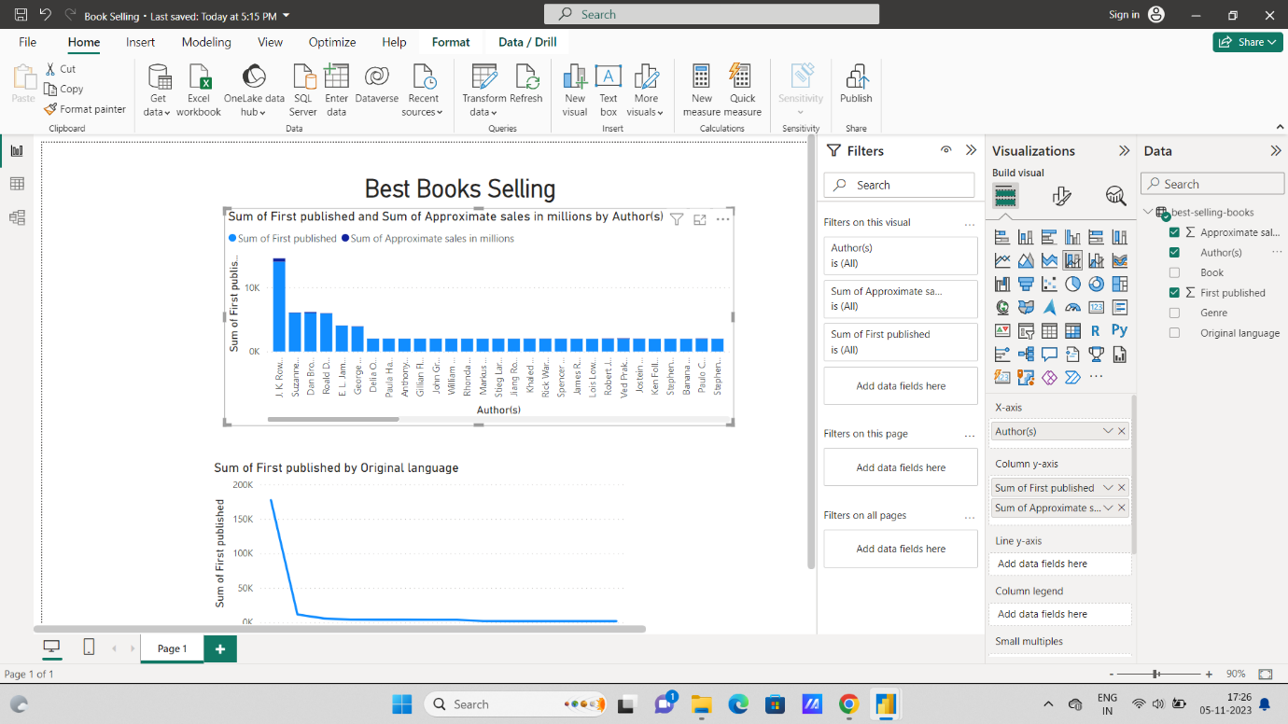

**Select Histogram Visualization:**

In the "Visualizations" pane on the right side of the screen, you'll see a gallery of visualization types. To create a histogram, click on the "Histogram" icon.

**Fields and Axis:**

In the "Visualizations" pane, you will see the "Fields" section.

Drag and drop the field that you want to create a histogram for onto the "Axis" section in the "Fields" pane. This field represents the data you want to visualize the distribution of.

Power BI will automatically generate a histogram based on the data distribution in this field.

**Customize the Histogram:**

You can further customize your histogram by using the "Visualizations" pane.

Adjust the number of bins (intervals or bars) by using the "Bins" option in the "Visualizations" pane. You can specify a fixed number of bins or a specific bin width.

You can format the axis scales, title, and other properties by using the formatting options in the "Format" section of the "Visualizations" pane.

**Interact with the Histogram:**

In the report view, you can interact with the histogram. You can hover over bins to see tooltips with details, zoom in on specific ranges, or cross-highlight related visuals by selecting bins.

**Save Your Report:**

Remember to save your report periodically by going to "File" and selecting "Save" to save your changes

**Decision :-** Analysis of hierogram chart Most of publish book writer is J. K Rollwing is more than 10k.

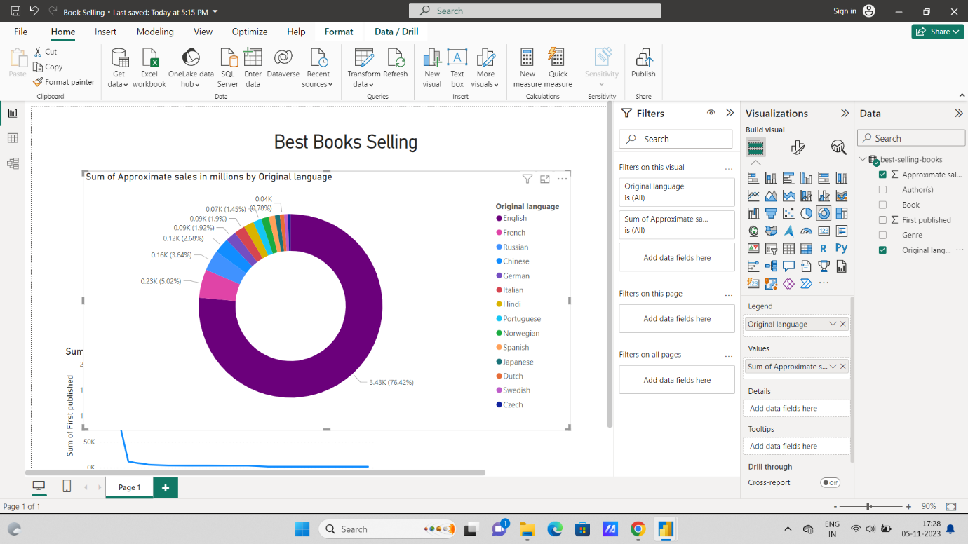

**Open Report View:**

In Power BI Desktop, click on the "Report" icon in the left-hand panel to enter the report view.

Select Pie Chart Visualization:

In the "Visualizations" pane on the right side of the screen, you'll see a gallery of visualization types. To create a pie chart, click on the "Pie Chart" icon.

**Fields for the Pie Chart:**

In the "Visualizations" pane, you will see the "Fields" section.

Drag and drop the field that you want to visualize as slices of the pie chart onto the "Legend" section in the "Fields" pane. This field represents the categorical data that you want to show in the pie chart.

Optionally, you can drag and drop another field onto the "Values" section if you want to represent the size of the slices with numeric values (e.g., counts or percentages). If you skip this step, Power BI will count the occurrences of each category automatically.

**Customize the Pie Chart:**

You can further customize your pie chart by using the "Visualizations" pane.

Format the title, labels, and legend in the "Format" section.

You can also explode a slice (pull it out from the pie) by clicking on it, which can help emphasize a specific category.

**Interact with the Pie Chart:**

In the report view, you can interact with the pie chart. You can click on slices to highlight them or select them for cross-filtering other visuals in your report

**Decision:-** Analysis pie char in Most of selling books language is English 76.42%.

